
DSC 550 – GRAPH ANALYSIS


March 25, 2022
SUBHASHINI NATARAJAN

Dataset introduction:

Data set used for analysis, provide import values of foods and beverages entering US ports. Data includes various food groups like vegetables, fruits, meat etc., value of food imported in million dollars over the span of ten years. The dataset helps us infer several details about the food that the United States, imports from other countries.

Dataset:

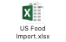

Questions to explore from the dataset:

- Which food group has the highest import value in the year 2021?
- What is the trend of import values over the years?
- What is the percentage of each food group’s import value as compared to overall value?

Graphs:

Bar plot:

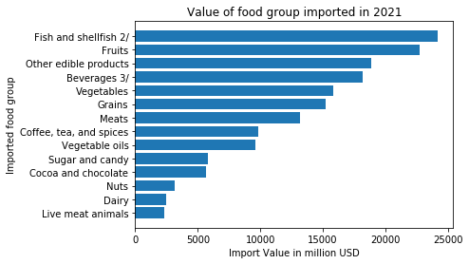
Learning: The graph gives the values of each food group imported in 2021. Using sorted data for the graph helps me infer the order of food groups based on their import value in million USD.

Line plot:

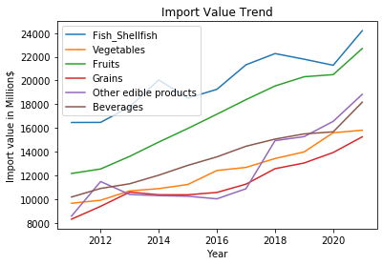
Data Learning:

The trend in import values for the top six food groups based on import value is charted. In the year 2020, there is a dip in all the import due to covid. Fruits show steep and steady increase as compared to other food groups. Beverages show a lot a variance in value each year as compared to other food groups, followed by Fish and Shell fish.

Pie Chart:

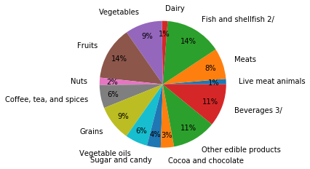

Data Learning: Pie chart gives the percentage of import value of each food group.

Summary:

Various charts helped answer the questions that food group with the highest import value in 2021 is Fish & Shell fish, the trend in import values over the span of years and percentage of import value of each food group.

